**Name :Hertika Batra**

**Roll:5**

**Batch : A**

**EXP 1: Installation and Configuration of Flutter Environment.**

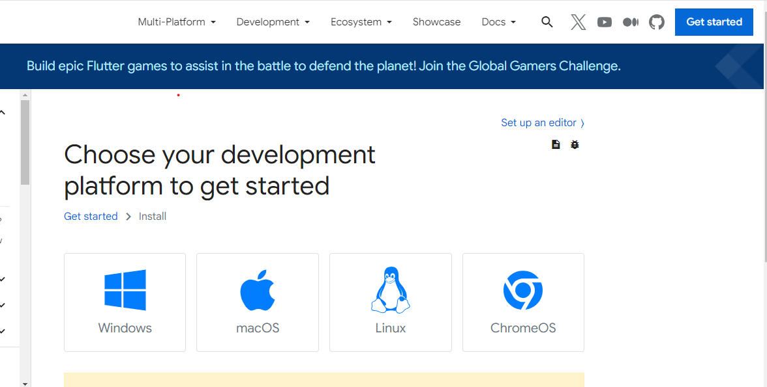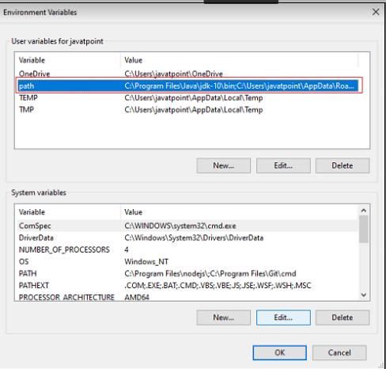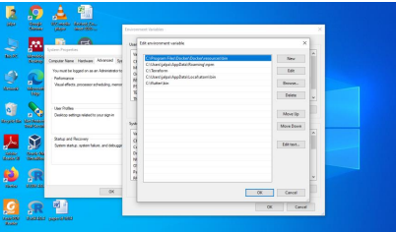

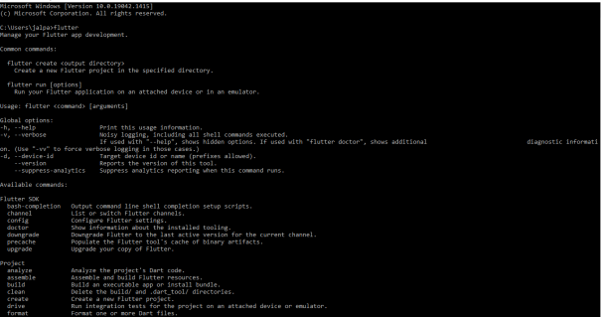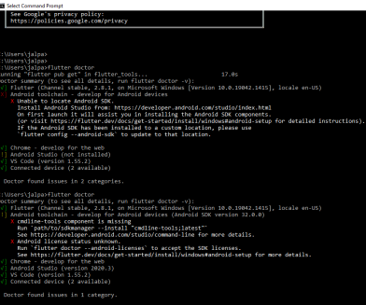

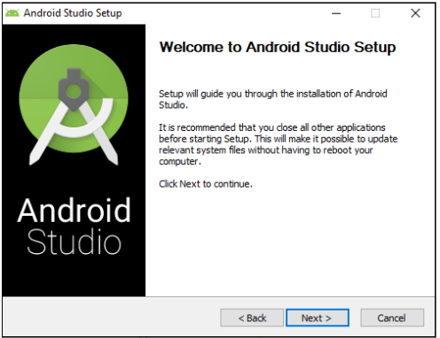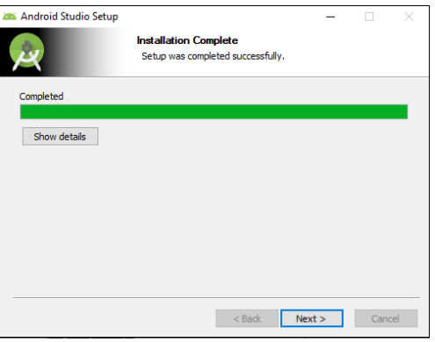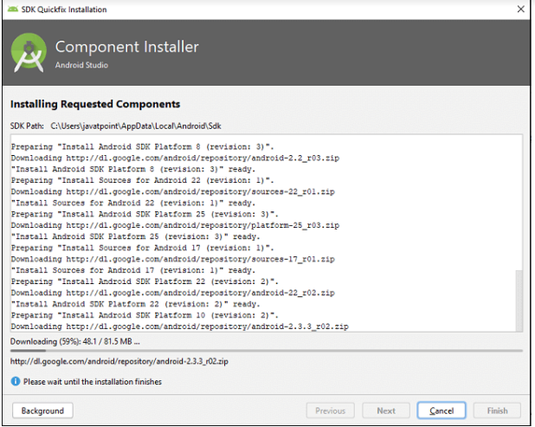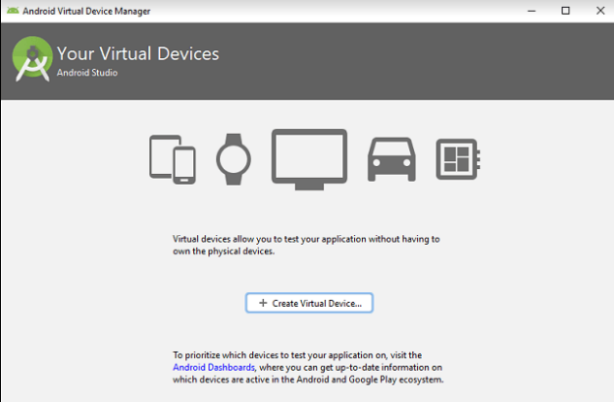

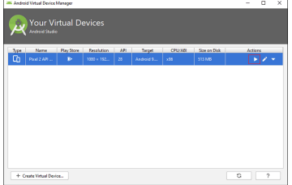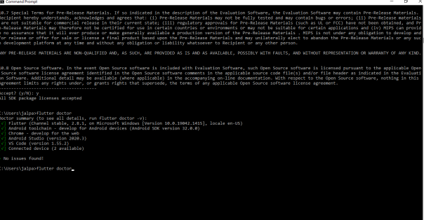

**Name :Hertika Batra**

**Roll:5**

**Batch : A**

**Experiment 2: Create a ‘Hello World App’ using Flutter**

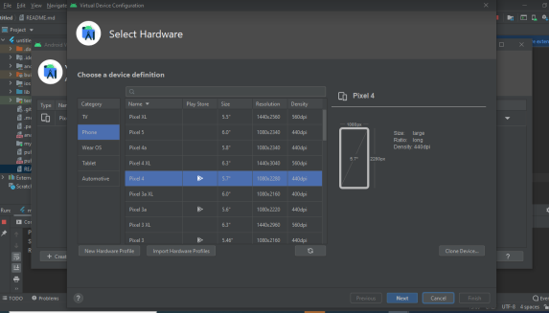

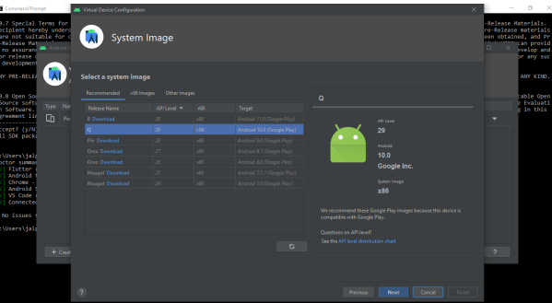

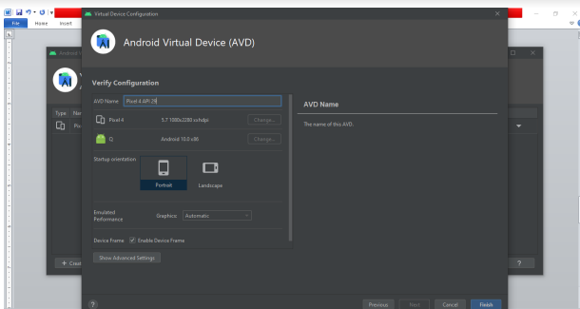

**code:**

import 'package:flutter/material.dart';

void main() {

runApp(const MyApp());

}

class MyApp extends StatelessWidget {

const MyApp({Key? key}) : super(key: key);

@override

Widget build(BuildContext context) {

return MaterialApp(

title: 'Welcome to Flutter',

home: Scaffold(

appBar: AppBar(

title: const Text('Welcome to Flutter'),

),

body: const Center(

child: Text('Hello Hertika'),

),

),

);

}

}

**output:-**

